Tim Fang

2021-Dec-05

Foundations of Programming (Python)

Assignment 08

Object Oriented Programming

# Introduction

This document will describe what I thought learned from Module 08, outline some of the steps I took for the eighth assignment, and summarize lots of challenges. Unlike previous assignments, I was unable to complete all the TODOs in time. I spent most if not all of my time creating the new CD object, integrating that object to add/process user input, and struggling with the FileIO. There was little time left to include error handling, make sure all the appropriate docstrings were in place, or zero in on all the program’s details to ensure a polished product. At this writing, it’s 9 PM, dinner never took place, and I’m mentally spent/frustrated yet again.

# Program Planning

The class IO was easier to tackle, so I began there. Then, I worked on the main body of the script, adding code where it aligned with IO functions. The concept of the new CD object was still raw, so I reviewed the class/group office recordings at least a couple of times as well as this week’s Module content. Every time I thought I understood enough to write code, I hit a wall with multiple erros.

# Final Script

The program I’ve submitted works at a very basic level, allowing the user to load from file, enter CDs, and save to file. There’s little to no error handling, so there will be crashes to reflect where I also crashed. The last time I felt this hopeless was with the lab for program arguments. There isn’t much content to screenshot, so I’ve focused on what the program is stable enough to perform.

Figure 1 shows a successful program start with data loaded from file and brought to screen by entering ‘I’.

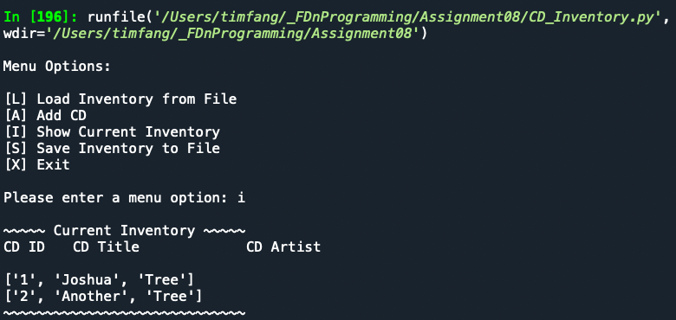

Figure 1 – CD Inventory after program start

Figure 2 shows the inventory after adding a new CD.

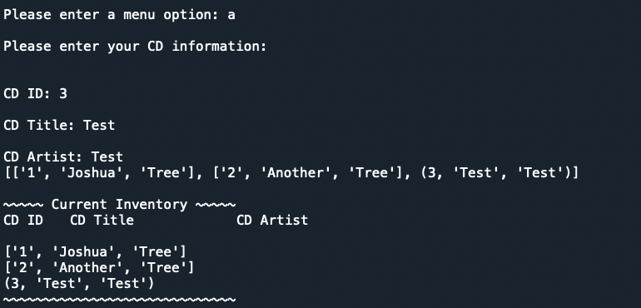

Figure 2 – CD Inventory after adding new CD

Figure 3 shows successful ‘S’ and ‘L’ options but notice the difference in the inventory between Figures 2 & 3. Only when saved to and loaded from file is the new CD changed to a list. I ran out of time to address that.

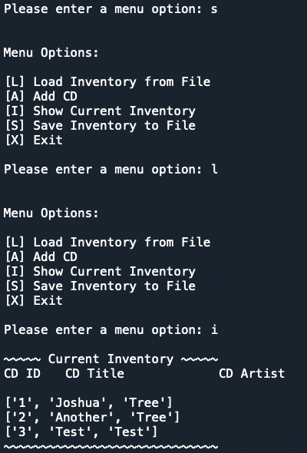

Figure 3 – CD Inventory after saving to and loading from file

Figure 4 shows a successful program load in Terminal with a new CD added to inventory.

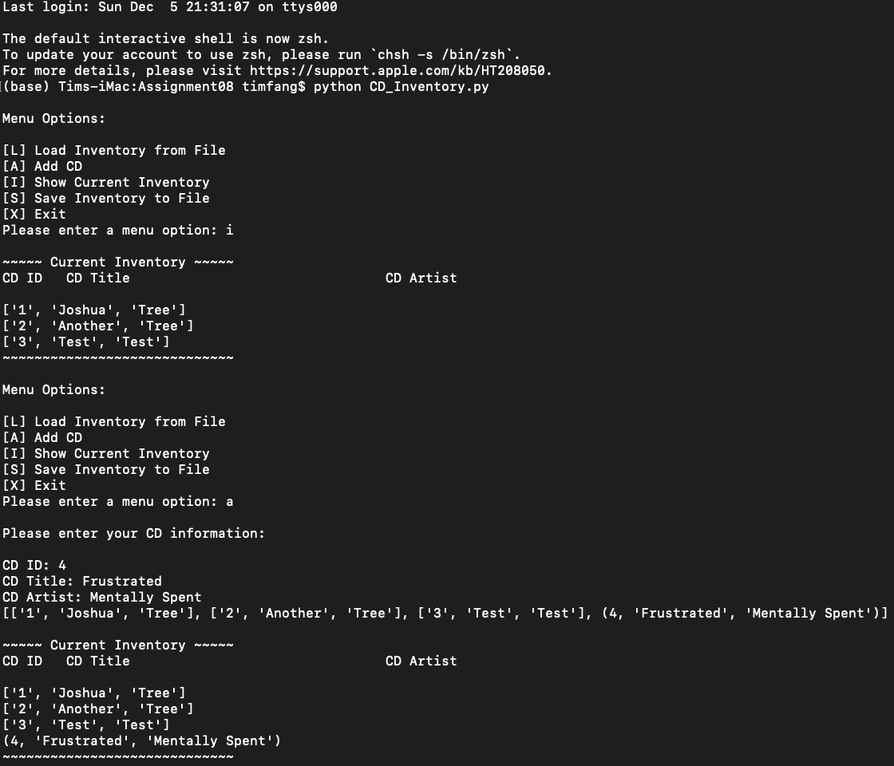

Figure 4 – CD Inventory in Terminal

Figure 5 shows the same functionality for ‘S’ and ‘L’ as in Sypder.

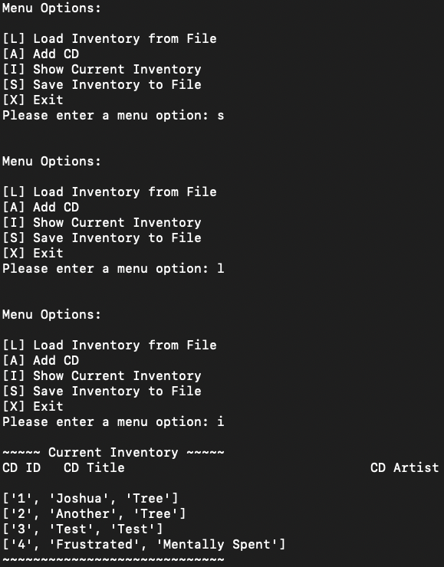

Figure 5 – CD Inventory in Terminal

# Summary

I’m beating a dead horse by repeating the following comment. I accepted that there would be a degree of work when the course began. I didn’t expect to spend all hours of my free time trying to understand the material and meeting each week’s deadline. Why have I heaped so much stress on myself each week?

# Appendix

<https://github.com/timsfang/Assignment_08>